Physics A Lessons

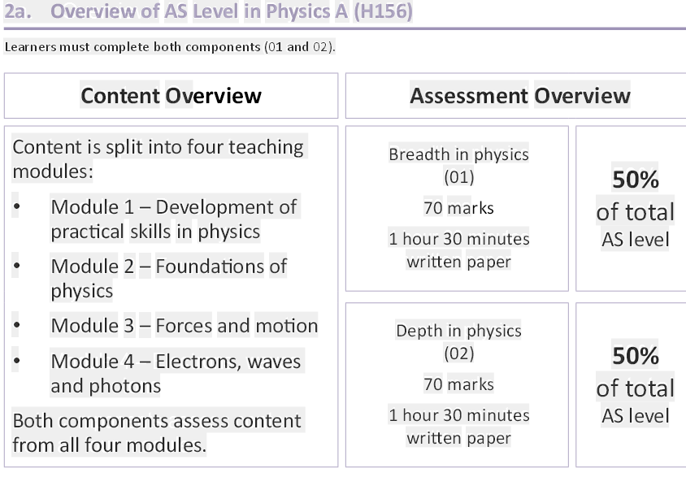

answers to Practice Questions

https://global.oup.com/education/content/secondary/series/ocr-a-level-sciences/alevel-sciences-for-OCR-student-book-answers/?region=uk

general good animations

fantastic! Mr Wayne
http://www.mrwaynesclass.com/teacher/home.html

nsw : more university type
http://www.animations.physics.unsw.edu.au/

all round revision (excellent)
doctor physics
https://www.youtube.com/user/DrPhysicsA

Bryanston
http://web.bryanston.co.uk/physics/APRG2004/RevGuide/RGch06.pdf

https://en.wikibooks.org/wiki/A-level_Physics_%28Advancing_Physics%29

Dr Physics
https://www.youtube.com/watch?v=2vsAY-tp9js&list=PL5D99A319E129A5B7

Page references below are to pages in Physics for OCR

car travel and slow down
http://phys23p.sl.psu.edu/phys_anim/mech/1D_kinematics_catchup.avi
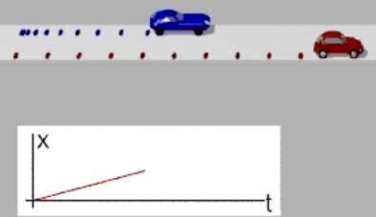

Page 50 Centre of Mass
https://www.youtube.com/watch?v=qRsJXXb9WNE

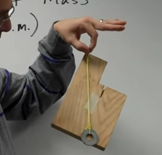

centre of gravity sumner miller: bit too much but v interesting
https://www.youtube.com/watch?v=YN2oALaRfL4

motion of centre of mass
http://www.mrwaynesclass.com/teacher/cm/home.html
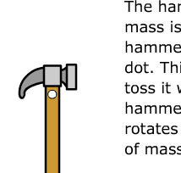

grav /kin energy
http://www.mrwaynesclass.com/teacher/Energy/coaster/home.html
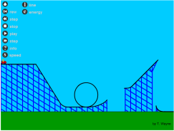

3rd Law
http://www.mrwaynesclass.com/teacher/NewtonsLaws/Rocket/home.html

3rd Law
http://www.mrwaynesclass.com/teacher/NewtonsLaws/weightlessness/home.html

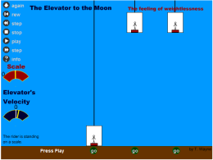

same up as down:
http://www.mrwaynesclass.com/teacher/vprojectile/Projectile_animation.htm

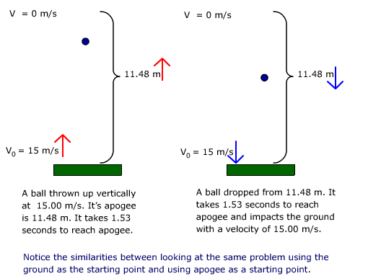

http://www.mrwaynesclass.com/teacher/vprojectile/independence.htm

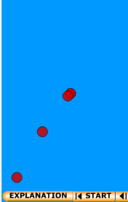

http://www.mrwaynesclass.com/teacher/vprojectile/table.htm

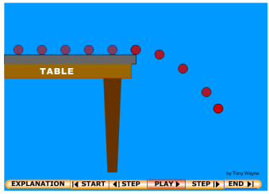

http://www.mrwaynesclass.com/teacher/vprojectile/Impact/home.html

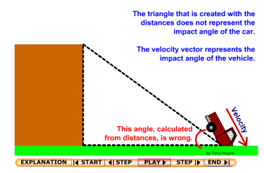
Drop passenger helicopter
http://www.mrwaynesclass.com/teacher/projectile/ProjectileCopter.swf

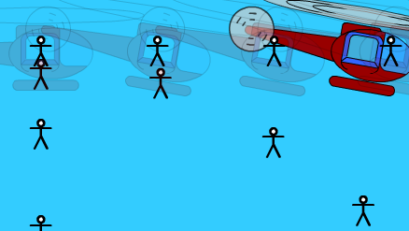

young extension
page 93 http://phys23p.sl.psu.edu/phys_anim/misc/youngs.avi

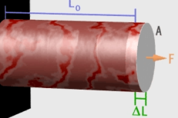

CH 8-10 ELECTRICITY page 118

resisitivity
https://phet.colorado.edu/sims/html/resistance-in-a-wire/latest/resistance-in-a-wire_en.html

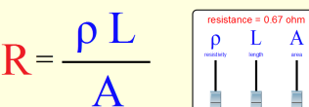

free electron metal and semi c.
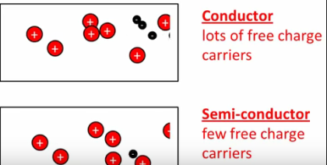
https://www.youtube.com/watch?v=JPnBzU3FKtc

ohms law
http://www.physics-chemistry-interactive-flash-animation.com/electricity_electromagnetism_interactive/resistance_ohm_law_1.htm
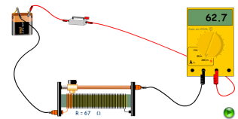

WAVES
standing wave
https://newt.phys.unsw.edu.au/jw/strings.html

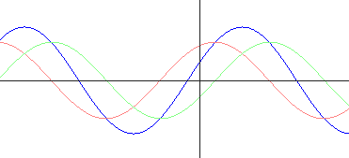

resonance tocoma bridge
oscillations_Tacoma.swf drag to browser
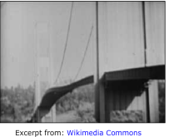

long, tranv
http://phys23p.sl.psu.edu/phys_anim/waves/Trans_n_Long.avi
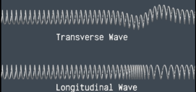

meeting waves
http://phys23p.sl.psu.edu/phys_anim/waves/pulsed_1.avi
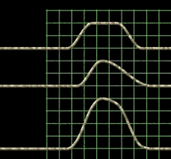

reflected inverted and not
http://www.animations.physics.unsw.edu.au/waves-sound/travelling-waves/index.html#2.2

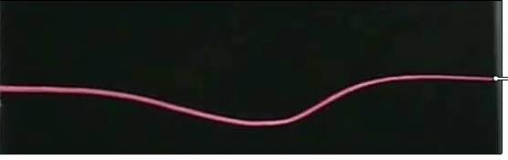

Page 32 Doppler

Doppler
http://www.animations.physics.unsw.edu.au/waves-sound/Doppler/index.html
doppler_ms_animation.swf
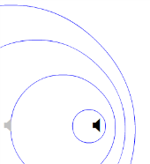

doppler_sonicboom.swf
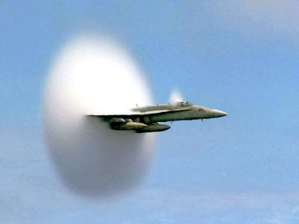
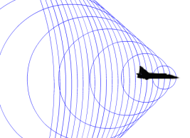

https://www.youtube.com/watch?v=fW2Y8DLwvxs&ebc=ANyPxKp3VU7odwBLfxxA3IEa2nGGU6LlvMSbudQrexI6jEObCW6IphjqVY4FgRGm440ehtGLNK-gatzhgyBeD9oMd26tkVcZBg

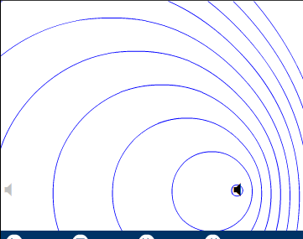

DIFFRACTION

young adjustable
http://micro.magnet.fsu.edu/primer/java/interference/doubleslit/

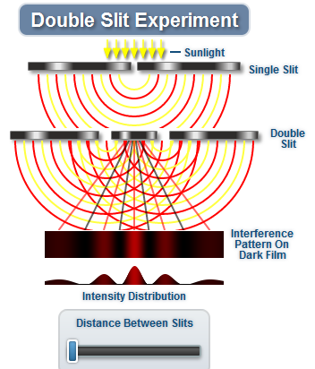

good fendt single slit
http://www.walter-fendt.de/ph14e/singleslit.htm

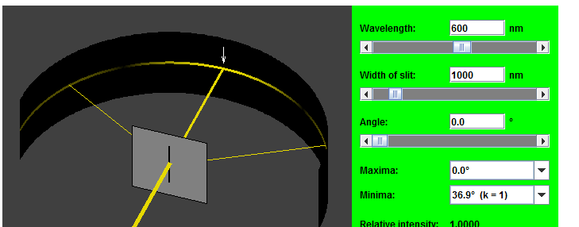

good fendt double slit
http://www.walter-fendt.de/ph14e/doubleslit.htm

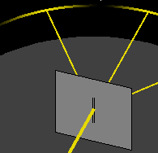

good double slit
http://www3.nd.edu/~ysun/Yang/PhysicsAnimation/collection/slitlight.swf

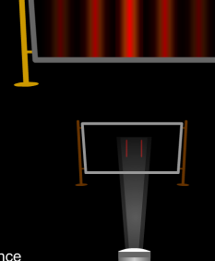

diffraction summary not animated
https://isaacphysics.org/concepts/cp_diffraction
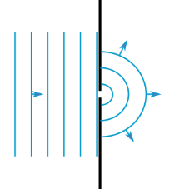

photoelectric effect
electron emitted
http://phys23p.sl.psu.edu/phys_anim/mod/x_ray_photoelectric.avi
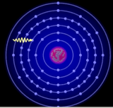

https://www.youtube.com/watch?v=v-1zjdUTu0o
charging by induction
electroscope discharge
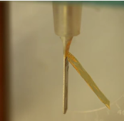

http://vlab.amrita.edu/?sub=1&brch=195&sim=840&cnt=4
edrobinson@hotmail.co.uk
cockatoo

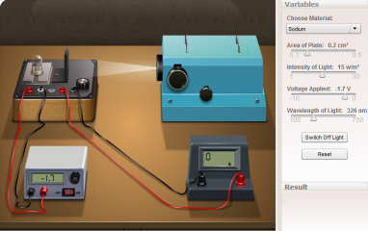

pe apparatus
https://www.pasco.com/prodCompare/photoelectric-effect-system/index.cfm
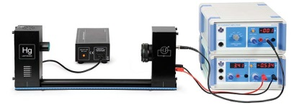

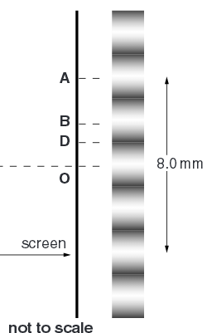
Queestion 1 page 235 Physics A text book Practice questions 12.

